Attached, you will find the application needed to complete your project. Kindly complete all sections and include three (3) sets of the required construction drawings and site plan.

Depending on your project, you may also be asked to submit some or all of the following items:
- Application Fee/Plan Review Fee
- Completed plot plan with all required information attached. (Please refer to sample provided)
- (3) Sets of detailed Construction Plans as applicable for all new construction, including additions and decks.
- Ground Coverage Percentage for new primary structures and/or additions to primary structures (impervious coverage divided by lot area), if applicable
- Contractor Certificate of Insurance naming Freemansburg Borough as certificate holder
- Workers Compensation Certificate of Insurance or Completed & Notarized WC Exemption Form (See attached Form).
- Copy of Water Supply Approval/Permit (if required)
- Copy of Driveway Permit (if required)
- Highway Occupancy Permit (if required)
- County Conservation District Approval (if required)
- Copy of Storm Water Approval/Permit (if required)
- Copy of Elevation Certificate (if required)
- All Property lines and proposed location of structure(s) must be marked on the site prior to submitting the application.
- Copy of signed contract detailing project and cost of Construction.

Questions? Call Suzanne Borzak- Keycodes Inspection Agency
610-866-2220 (x105) or e-mail zoning@boroughoffreemansburg.org

WORKER’S COMPENSATION INSURANCE COVERAGE INFORMATION
(attach to building permit application)

A. The applicant is a contractor within the meaning of the Pennsylvania Worker’s Compensation Law.
Yes No
If the answer is “yes", complete Section B or C
If the answer is “no” complete Section C below.

B. Insurance Information:
Name of Applicant _

Federal or State Employer Identification No.

Applicant is a qualified self-insurer for Workers’ Compensation
Original Certificate attached.

Name of Workers’ Compensation insurer

Workers’ Compensation Insurance Policy No.
Original Certificate attached.

C. Exemption. MUST BE NOTAIIIZED...

Complete Section C if the applicant is a contractor or homeowner claiming exemption from providing Workers’ compensation issuance.
The undersigned swears or affirms that he/she is not required to provide workers' compensation insurance under the provisions of Pennsylvania’s Workers’ Compensation Law for one of the following reasons, as indicated.

Contractor with no employees. Contractor prohibited by Law from employing any individual to perform work pursuant to this building permit unless contractor provides proof of insurance to the Township.

Homeowner who elects to perform all of the work without contracting or hiring others to assist.

Religious exemption under Worker’ Compensation Law.
Signatures of applicant:

Commonwealth of Pennsylvania County of

On this, the day of , 20 , before me the undersigned officer, personally appeared , known to me (or satisfactorily proven) to be the person whose name subscribed to the within instrument and acknowledged that she/he executed the same for the purposes therein contained.

In witness whereof, I hereunto set my hand and official seal.

Notary Public

OFFICE USE ONLY:
Date Received: ______________ Zoning District:______________ Tax Parcel No.:_______________________
Zoning Permit No.:______________________ UCC Permit No.:____________________________
□ Zoning □ PA UCC Construction

Application is hereby made for a permit in conformity with requirements of the PA UCC, Pennsylvania Municipalities Planning Code, Current Local Zoning Ordinance and any amendments thereto for the following described work:
PROPERTY INFORMATION
- Residential: One Family Two Family Manufactured □Non-Residential
Proposed Work Site Address: | Tax Parcel ID:
Lot Width: | (Acres or Sq.ft.)  Lot Depth: Lot Size:
CONTACT INFORMATION
Applicant:

Mailing Address: | City: State: Zip:
Phone: | E-mail:
(If different than Applicant)
Property Owner:
Mailing Address: | City: State: Zip:
Phone: | Email:
Contractor:
Mailing Address: | City: State: Zip:
Cell: | Email:
CONSTRUCTION

- Erect a Structure: Principal or Accessory Size (length, width, height)____________________________________
- Add to Structure: Principal or Accessory Size (length, width, height)___________________________________
- Change of Use: Existing:___________________________ Proposed:_______________________________
- Erect a Fence: Height:_____________
- Install Swimming Pool: Above Ground or In-ground
- Erect a Sign (Provide sign proof along with plot plan) or Sign Copy Change (Provide sign proof)
Type: Wall mounted, Ground, Roof, Other:_____________________
Height (distance from top of sign to ground)______________ Size (Length & Height of Sign Face)___________________________
- Off Street Parking Area or Parking Lot:__________________________________________________________
- Establish a Home Occupation (Type):___________________________________________________________
- Other:___________________________________________________________________________________

PROJECT DESCRIPTION Provide a narrative which explains the proposed project based upon the items checked in the previous section (III)
PLOT PLAN- PLEASE INCLUDE THE FOLLOWING:

- Indicate the length of all property lines

- Show all existing and proposed structures on property and the distance from the structure to the property lines

- Indicate name of streets abutting property

- Identify all bodies of water and show distance to proposed structure(s)

- Show septic, well, driveway locations and distance from new structure to septic

- Label distances from principal structure to proposed accessory structure(s)

- Physically mark property lines & proposed location of structure onsite prior to submitting zoning application

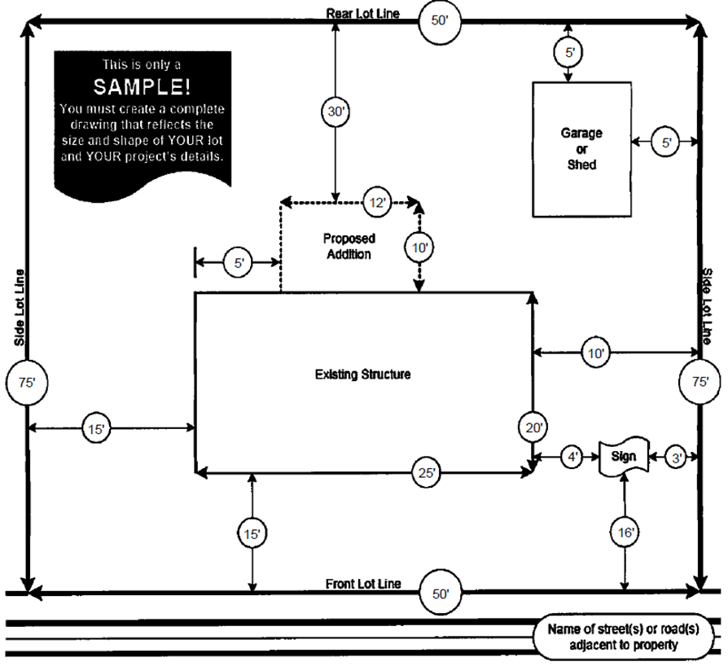

** PA UCC OFFICE USE ONLY **

APPLICANT’S CERTIFICATION

As the owner or the authorized agent of the project for which this application is filed, I certify that:
- The estimated construction cost and all other information provided as part of this application for a building permit is correct.
- The building or structure described in this application will not be occupied until all known code violations are corrected and a Certificate of Occupancy has been received from Building Code Official.
- This project will be constructed in accordance with the approved drawings and specifications (including any required non- design changes) and the Uniform Construction Code standards as specified in 34 PA Code Chapters 401-405.
- Any changes to the approved documents will be filed with the Building Code Official.
- If the licensed architect or engineer in responsible charge of this construction should change, written notice of the change will be provided to the Building Code Official.
- When required, up to 20% of the total cost of any work performed on an area of primary function in an existing building will be expended to provide an accessible route to the area of primary function or other approved accessibility improvements.
- No error or omission in either the drawings and specifications or application, whether approved or not, shall permit or relieve me from constructing the work in any manner other than provided for in 34 PA Code Chapters 401-405.

I hereby authorize the Municipality Staff to perform inspections related to this application as may be required between the hours of 8 AM and 8 PM. The applicant understands and agrees to comply with the Pennsylvania Municipal Planning Code and Zoning Ordinance, as amended. All information supporting this application shall become part of the records of the Municipality, cannot be returned and may be examined by the public at any time during the normal working hours of the Municipal Office

Application is hereby made for a permit to erect or alter a structure which shall be located as shown on the attached diagram/plot plan and/or to use the premises for the purposes herewith. The information which precedes, together with the plot plan/diagram, is made part of this application by the undersigned. It is understood and agreed by the applicant that any error, misstatement or misrepresentation of material, fact, either with or without intention on the part of this applicant, such as might or would operate to cause a refusal of this application or any change in the location, size or use of structure or land made subsequent to the issuance of this permit without approval of the Zoning Officer, shall constitute sufficient ground for the revocation of this permit.

Applicant Signature: Date:
Owner Signature: Date:
BOTH SIGNATURES ARE REQUIRED IF APPLICANT IS DIFFERENT THAN OWNER

*(3) SETS OF DETAILED CONSTRUCTION PLANS MUST BE SUBMITTED WITH ALL PA UCC APPLICATIONS.

*ALL COMMERCIAL CONSTRUCTION PLANS MUST BE PREPARED, SIGNED & SEALED BY A LICENSED DESIGN PROFESSIONAL FAILURE TO FILL OUT THE PERMIT APPLICATION COMPLETELY MAY RESULT IN DELAYS
OR REJECTION OF APPLICATION

