600 Monroe Street  Freemansburg, PA 18017-7280  Phone: (610) 866-2220  Fax: (610) 868-2402  www.boroughoffreemansburg.org | 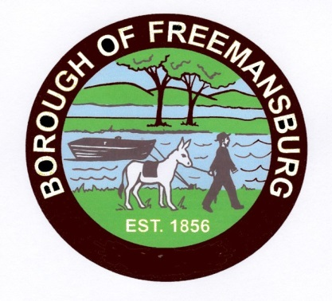 | Donald Lasso, Mayor  Homer G. Lorrah, Council President  Gerald J. Gasda, Borough Mgr.

RIGHT TO KNOW REQUEST

DATE REQUESTED

REQUEST SUBMITTED BY: E-MAIL US MAIL FAX IN-PERSON

NAME OF REQUESTOR:________________________________________________

STREET ADDRESS: _____________________________________________________

CITY/STE/ZIP/COUNTY:_________________________________________________

TELEPHONE:___________________________________________________________

E-MAIL ADDRESS:_______________________________________________________

RECORDS REQUESTED:__________________________________________________
__________________________________________________________________________
__________________________________________________________________________
__________________________________________________________________________
__________________________________________________________________________

DO YOU WANT COPIES? YES NO

DO YOU WANT TO INSPECT THE RECORDS?

DO YOU WANT CERITIFED COPIES OF RECORDS?
___________________________________________________________________________

RIGHT-TO-KNOW OFFICER:_______________________________________________

DATE RECEVIED BY THE AGENCY:_________________________________________

AGENCY FIVE (5)-DAY RESPONSE DUE:______________________________________

*Public bodies may fill anonymous verbal or written requests. If the requestor wishes to pursue the relief and remedies provided for in this Act, the request must be in writing. (Section 702) Written requests need not include an explanation why information is sought or the intended use of the information unless otherwise required by law (Section 703).
(Form updated 12/14/18)

